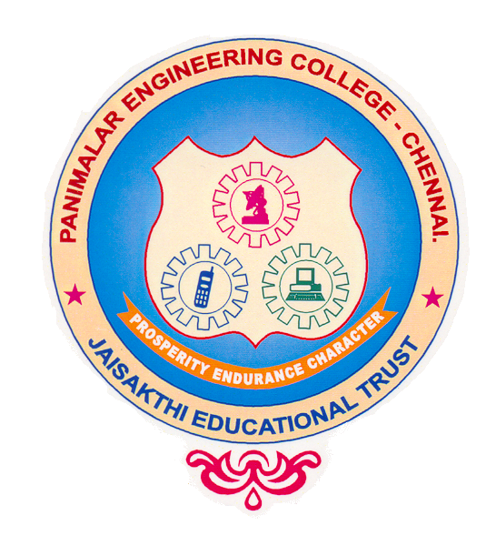 PANIMALAR ENGINEERING COLLEGE
Chennai – 600 123
Department of Computer Science & Engineering
CS 8811 - Project Work (2021 -2022)

ZEROTH REVIEW FORM

TILE OF THE PROJECT

AI based rectal cancer and stage prediction over web in real-time for general users.

ABSTRACT

With the development of targeted therapies, many treatments are based on molecular studies, which require sampling tumour tissue from paraffin blocks for sequencing. An automated solution could potentially reduce the workload of pathologists by acting as a screening device and may reduce the subjectivity in diagnosis. In tissue-based diagnostics, most of the work still needs to be done manually by a pathologist using a microscope to examine stained slides. The foundation of such tasks is to accurately distinguish cancer/malignant cells from normal/benign cells. However, the determination of tumour content is poorly reproducible with significant variation. As the size of tumour regions can be very small, pathologists are often required to use high magnification for detecting tumour cells. This requirement significantly increases the workload for pathologists. As digital pathology datasets have become publicly available and have opened up the possibility of evaluating the feasibility of applying deep learning techniques to improving the efficiency and quality of histologic diagnosis. In this project we introduce an user facing AI based application to detect and predict the stage of Rectal cancer based on CNN with Attention mechanism and Ranking algorithm.

TECHNOLOGY

Artificial intelligence (AI) -> Convolutional Neural Networks (CNN) with Attention Mechanism
+
RANKING

Front end -> Web page { Flask + Azure VM

LIST OF REFERENCES

- Data set : https://zenodo.org/record/53169#.Yb8SEtvhXEp
- Base paper: https://ieeexplore.ieee.org/document/9044355

ENCLOSE A COPY OF THE BASE PAPER

